Assignment no-1

Class-SEIT RollNo-SI49

/*PROBLEM STATEMENT:-

1. Write an Embedded C program to perform addition of two numbers.

*/

//Source Code:-

#include <xc.h>

#include <stdio.h>

#include <stdlib.h>

#include <pic18f4550.h>

void main(void) {

int a=10,b=30,sum;

sum=0; //Initializing sum as zero

sum=a+b;

TRISD=0; //Initialize Port_D as output

PORTD=sum;

}

************************************OUTPUT***************************************

1)I/O VIEW

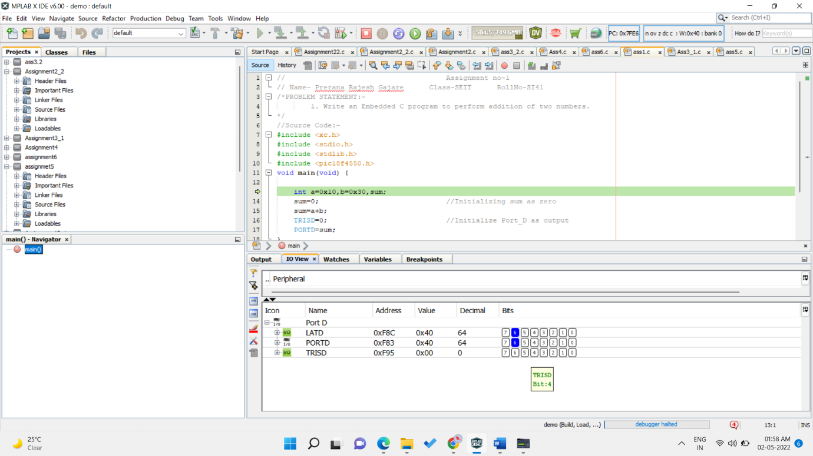

2)PICSIMLAB OUTPUT

